Matlab simulation about Hovering and landing motion:

* All needed files are integrated in folder: >> Core >>MATLAB_State_Space_Controller

>> BasicProject.

* To run these Matlab files, we need to install a compiler and active it with “mex –set up”.
* Run m-file “Reglerauslegung.m” to read parameters.
* Open Simulink file “System_Design_Quadrocopter_2012.mdl”.

Then you can see the following picture:

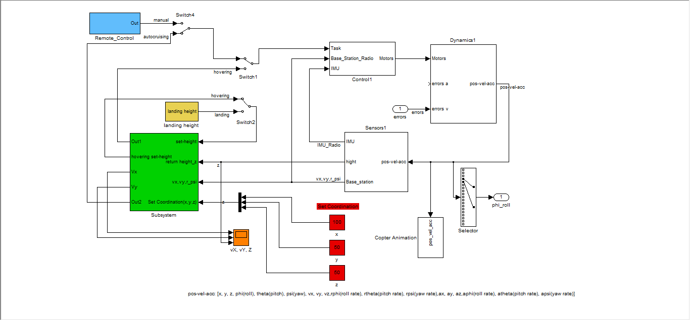

**#1. Auto cruising:**

* + Use “set coordination” blocks (red blocks) to set destination coordination(x,y,z).
  + Use switch4 to select manual control and auto cruising.

Note that Auto cruising should be done in first step. Because currently auto cruising controller is not so good therefore if do auto cruising after any other motion, the copter is going to unstable.

**#2. Manual controlling**

* Set remote controller inputs in “Remote_Control”(light blue block).
  + Set Pitching angle by modifying “theta_set”.
  + Set rolling angle by modifying “phi_set”.
  + Set yawing angular velocity by modifying “rpsi_set”.
  + Set the thrust by modifying last block.
  + Switch 4 to manual node to control copter with remote controller.

**#3. Hovering**

* In green block, there are “Hovering controller”, “Cutoff switch”, “coordination system shifting”, “AutoCruising Mode” and “hovering height setting” blocks.
  + Flip switch1 to hovering node, copter can change to hovering mode.

**#4. Landing**

* + Set landing height with modifying constant block “landing set_height” from “landing height” block (yellow block).
  + Use “switch2” to switch into landing motion.